**Unity Version:** 2021.3.3f1c1

**Resolution:** 1920 x 1080

**Project Settings:**

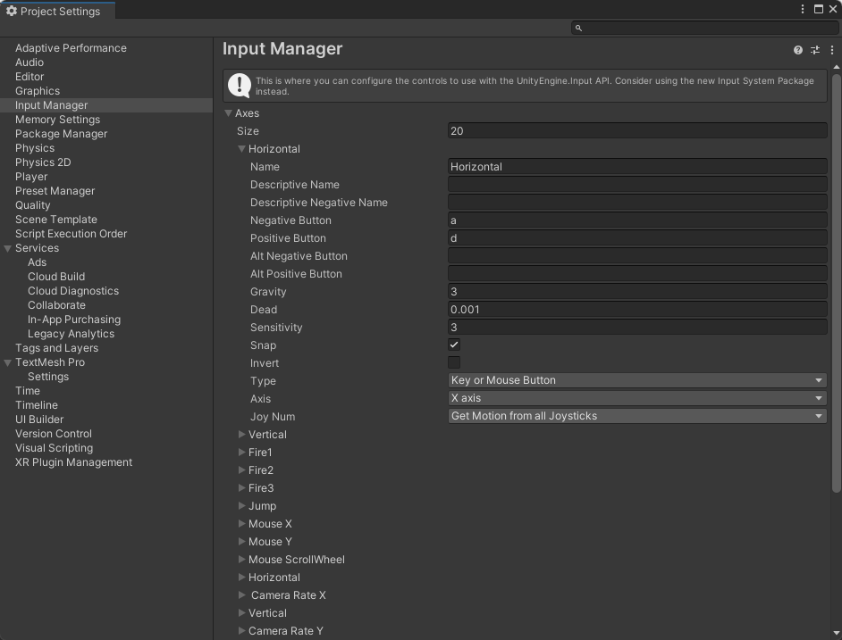

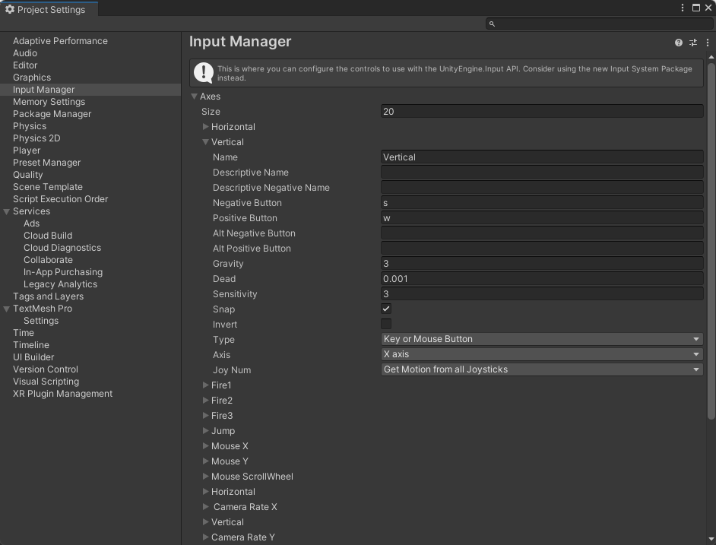

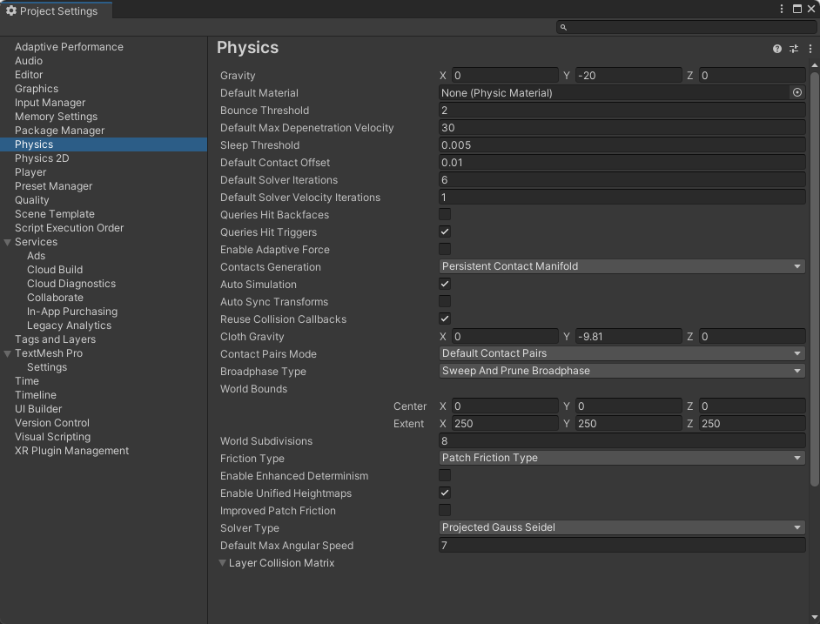

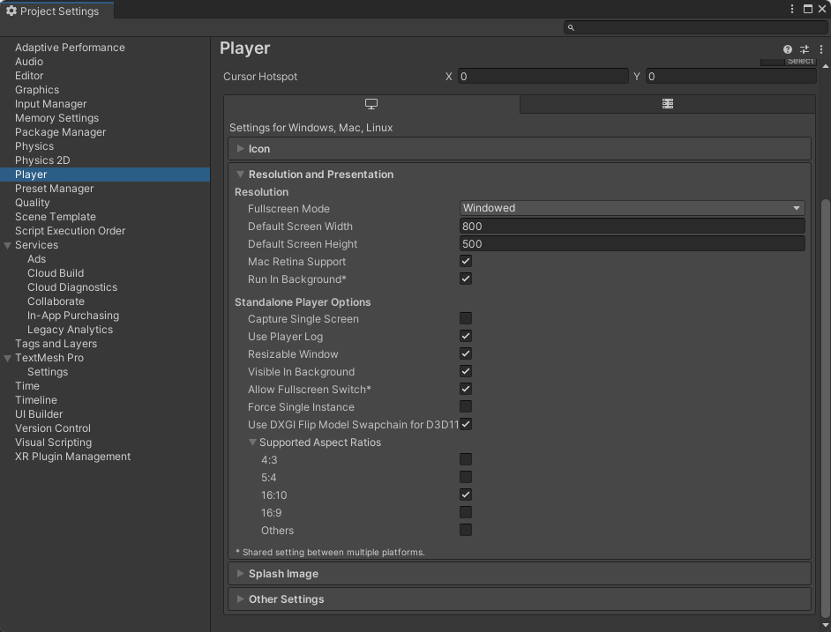

**Build Settings:**

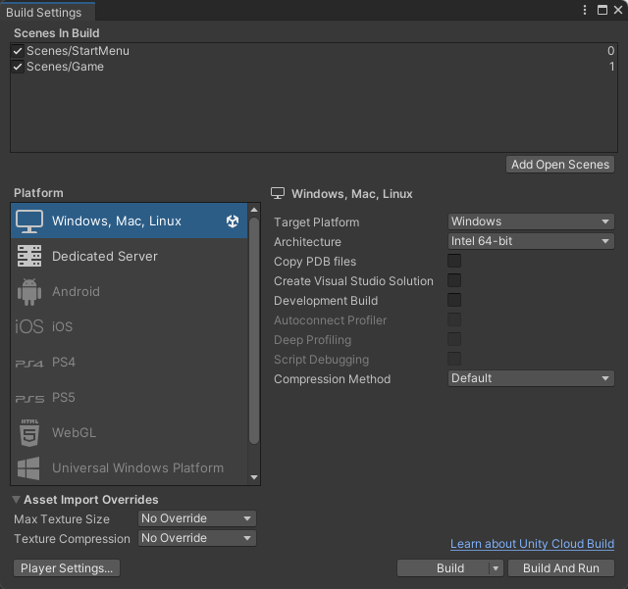

**Game Objects:**

|  |  |
| --- | --- |
| **Character** | **Object** |
| Player | The white chicken |
| Creature | Small red water drop-shaped monsters are the enemies to avoid. Loses 20 HP if player is caught. |
| Bonus | Gold coins. Each is worth 10 scores. |
| Bases | Cylindrical white gift box. If it is touched, the player will get a random super ability, the enemies will destroy it and create a new enemy. |
| Trees | Decorative objects. |

**Scenario:**

|  |  |
| --- | --- |
| Scalable Hills | There are three hills to climb on the upper left, lower left and upper right of the plain. |
| Plain | The center of the terrain. Mostly green grass with trees and three paths that meet in the center. |
| Toxic dry grass field | It's on the upper right of the plain. A square field of dry grass in which the player loses health over time. |
| Barriers | A ring of mountains at the edge of the terrain. Used to prevent the player from seeing the edge of the terrain. |

**Gameplay Settings:**

|  |  |
| --- | --- |
| Base Change | If touched by the player, the lid of the gift box will disappear, indicating that the player has received gift superpowers. |
| Superpower | 1. The player's walking speed has tripled. At this point the player glows gold. Players cannot run when they reach super speed due to the speed limit specified.  2. Player takes half the damage from monsters. The player emits a blue light. If the player has two superpowers at the same time, the light will look green. |

**Menus:**

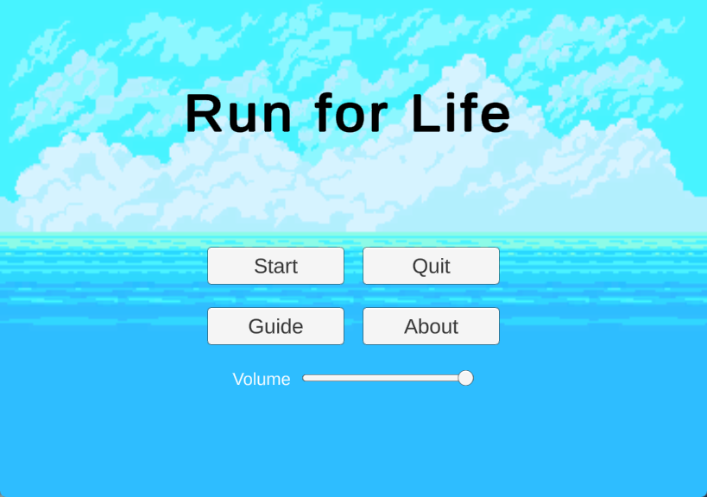

Start: Start a new game.

Quit: Exit from the game.

Guide: Show the game introduction.

About: Show the developer information.

Volume: Control the audio volume.

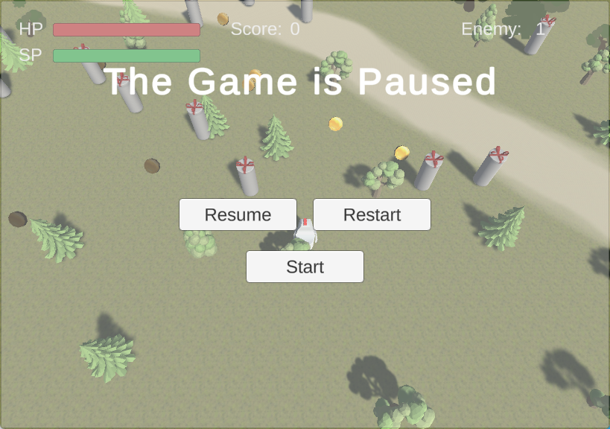

Resume: Back to the game and continue game play.

Restart: Start a new game.

Start: Back to the start menu.